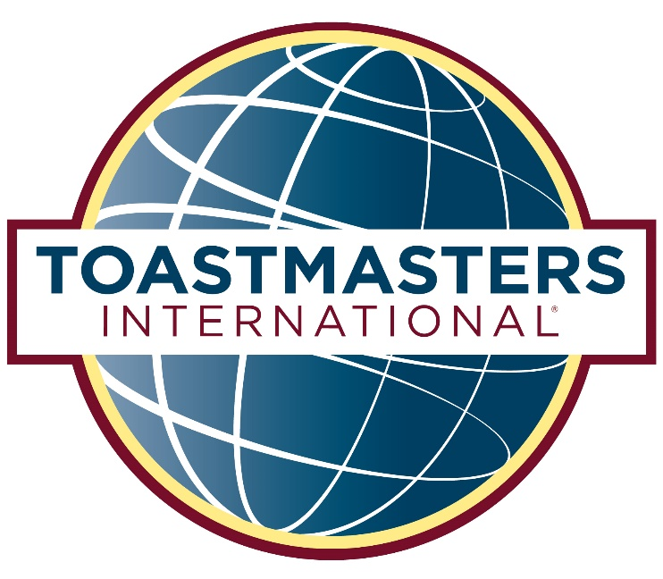

THANK YOU  
FOR YOUR SUPPORT

Many thanks to all who contributed their time, talents, and efforts to make this contest possible. We could not do it without you!

Today’s 1st place winners will move up to the next level of contests. Please support them by attending:

# Area X50 Contests

## Saturday, November 17

**Apple Computer**

12545 Riata Vista Circle

Austin, TX 78727

# District 55 Fall Conference

## April 12-14, 2019

**Emerald Beach Hotel**

Corpus Christi, Texas

Register by ____________ and pay only $___

First-Timers receive a $___- discount

CLUB NAME

TALL TALES AND

INTERNATIONAL SPEECH CONTESTS

www.tmd55.org

### Saturday, November 3, 2018

Apple Computer  
12545 Riata Vista Circle

Austin, TX 78727

FUNCTIONARIES

Contest Chair Jane Deaux

Toastmaster Sir Speaks a Lot

Chief Judge Frank Smith

Ballot Counters John Smith, Nomad Jones,

Jane Smith

Timers Joe Second, Don Hour

Sergeants-at-Arms Military Smit, GI Joe

Refreshments Chair Mary Drink

(In Alphabetical Order)

# Tall Tales Contest

Joseph Bousquet

Darleen Gilmore

Brian Isaac

David O’Malley

# International Speech Contest

Desmond Calloway

Susannah Erler

David O’Malley

Olu Olusanya

## Opening Remarks

## Welcome & Introductions

John Deaux, Contest Chair

## Contest Opening

Jane Deaux, Toastmaster

## Contest

## Interview Contestants

## Recognition of Contest Team

## Announcements

## Presentation of Awards

PARTICIPANTS

PROGRAM SCHEDULE